**ASSIGNMENT 2**

**Q1**. **Change the umask value of a user permanently.**

**Solution:** We can setup umask in /etc/profile or ~/.bashrc or /etc/login.defs file for all users.

Enter $ sudo gedit /etc/profile or $ sudo gedit ~/.bashrc or sudo gedit /etc/login.defs command on the terminal. (sudo is used since not logged in to root user).

For /etc/login.defs file, search for line where the following is written

ERASECHAR 0177

KILLCHAR 025

UMASK 0022

Change the umask value to say 007 and then simply logout and login back. Also change the entry USERGROUPS_ENAB yes to no to enable the new umask value permanently to users.

Now login to any user (say user g, in my case), on giving the command umask on terminal the output will show the new umask value, that is, 0007

Following are the screenshots of the process:

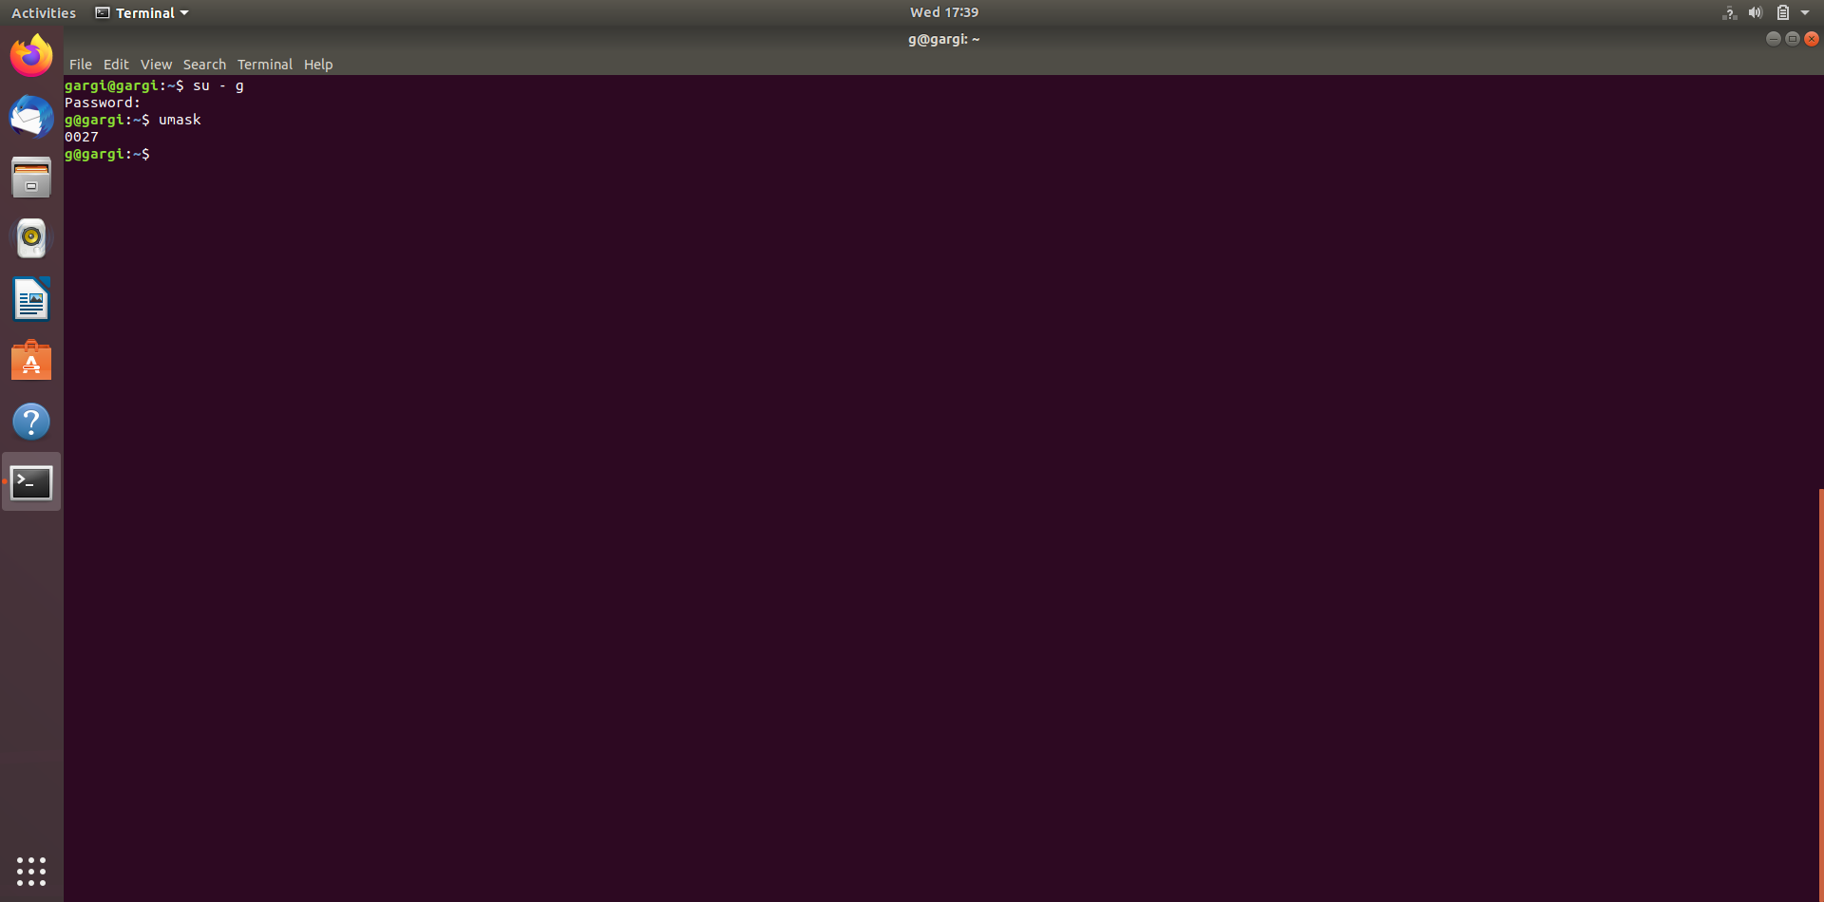

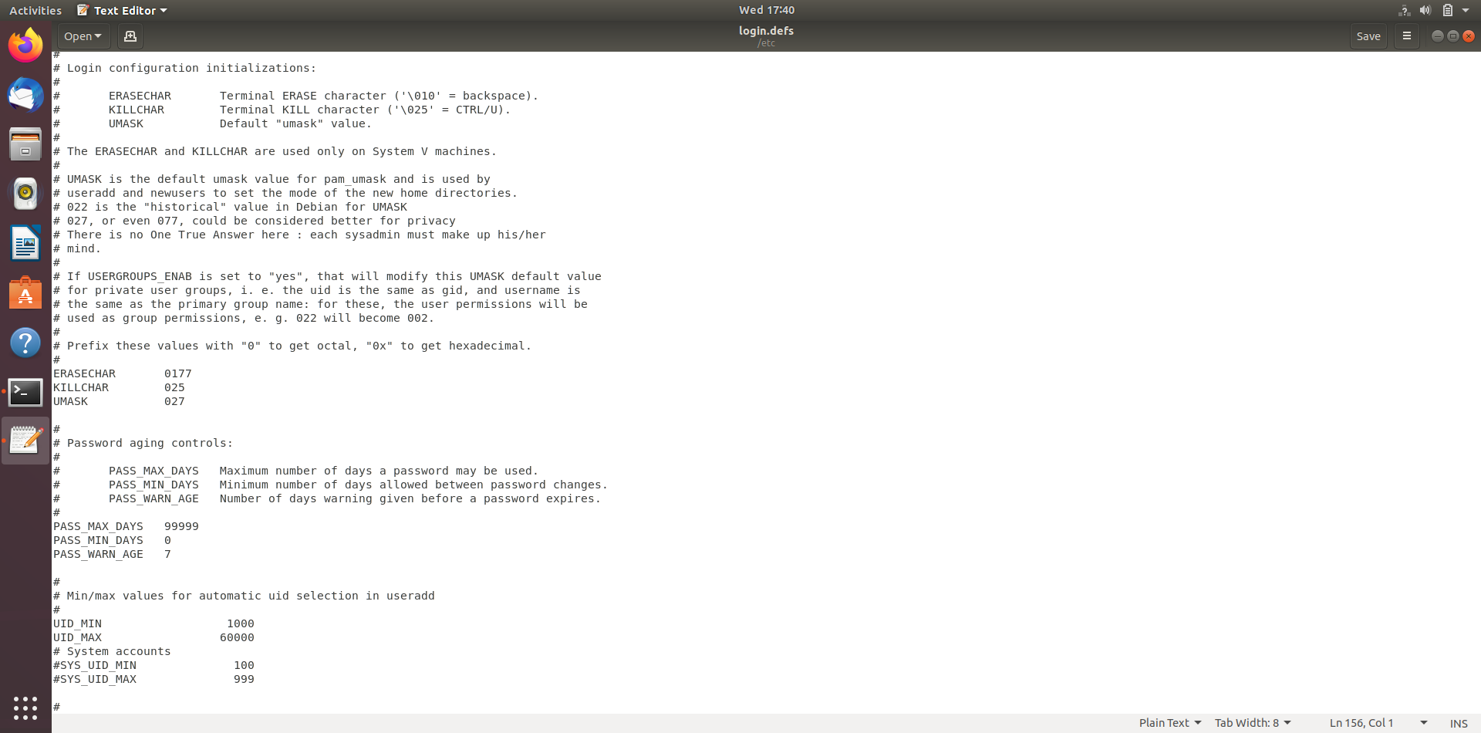

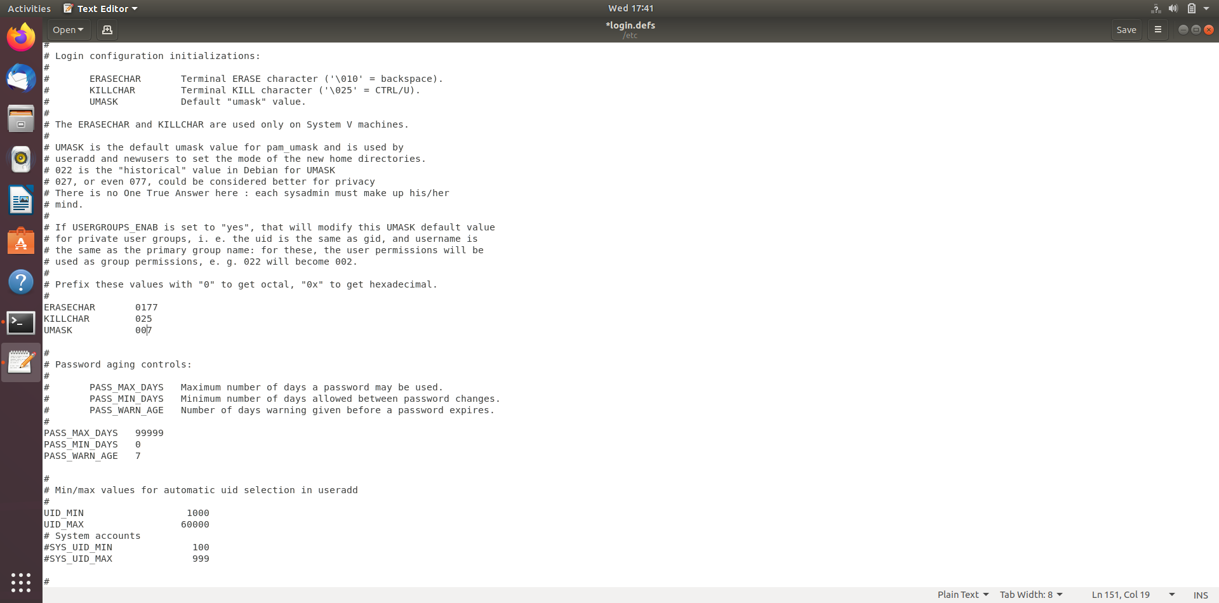

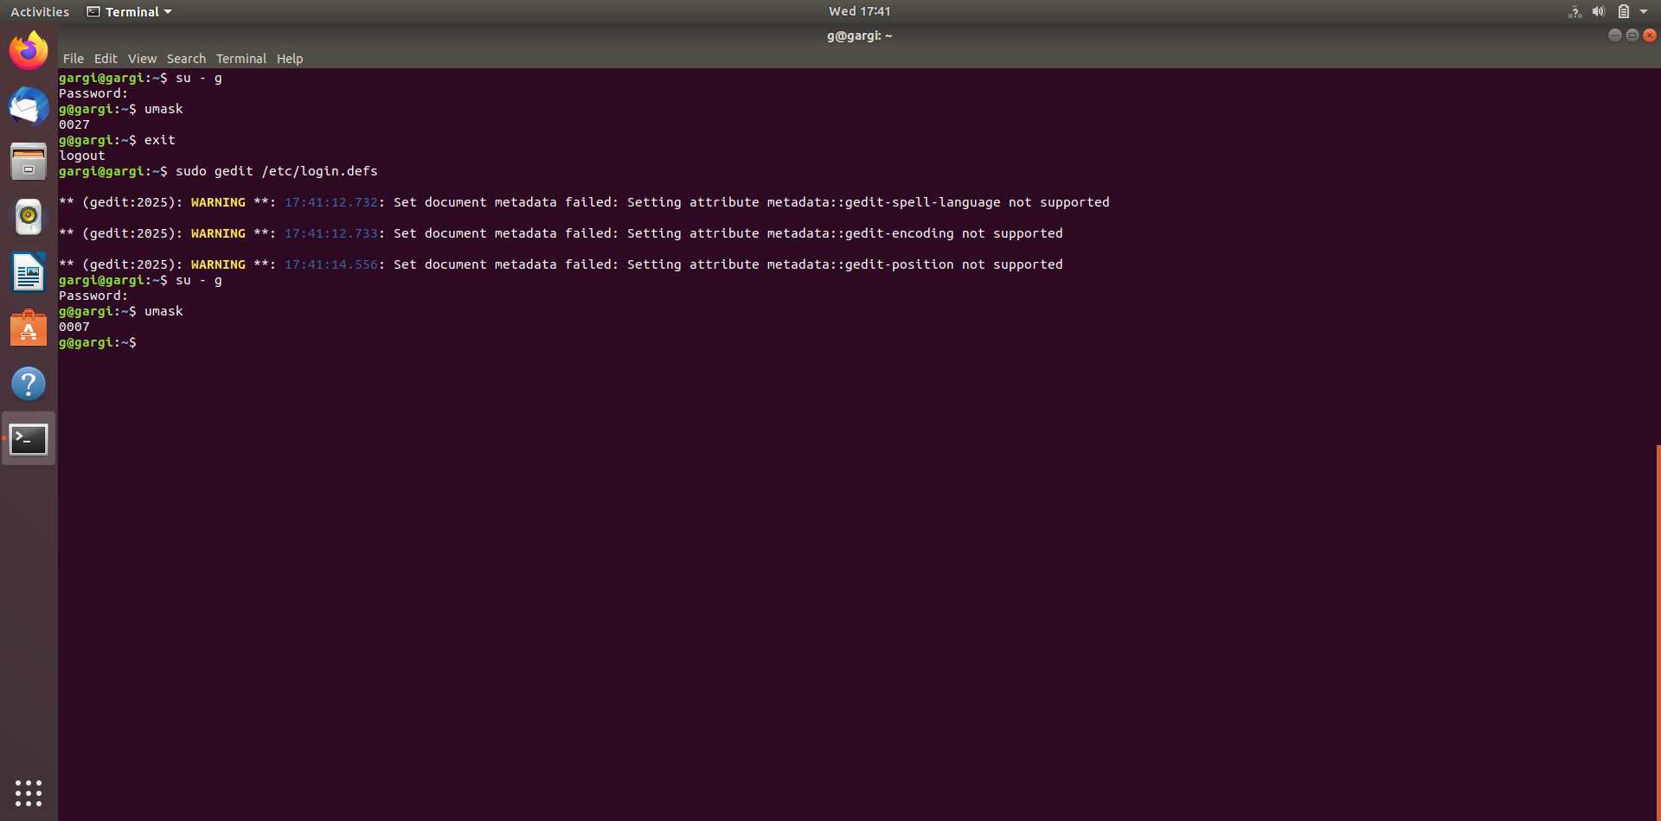

**Q2. Add user without using adduser and useradd command**

**Solution:** To add user without using adduser and useradd commands, follow the following steps:

1. Add entry for user in /etc/passwd file using $sudo gedit /etc/passwd
2. Add entry for the group in /etc/group file using $sudo gedit /etc/group.
3. Create home directory for the added user.
4. Set the new user’s password using the passwd command.

**Q3. Can we change the Umask value to 0888. If yes, then how. If no then why?**

**Solution:** No, we can not change the umask value to 0888. Even if we try to do so it will automatically take the default value which is 0022.

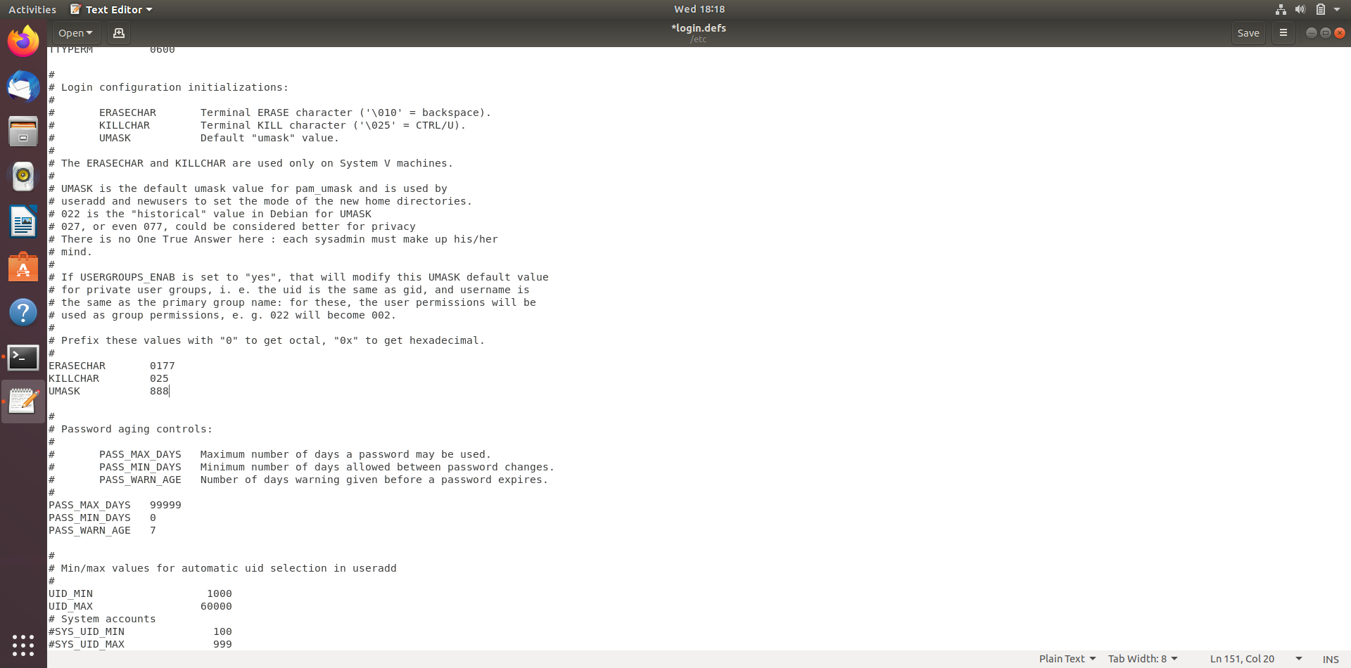

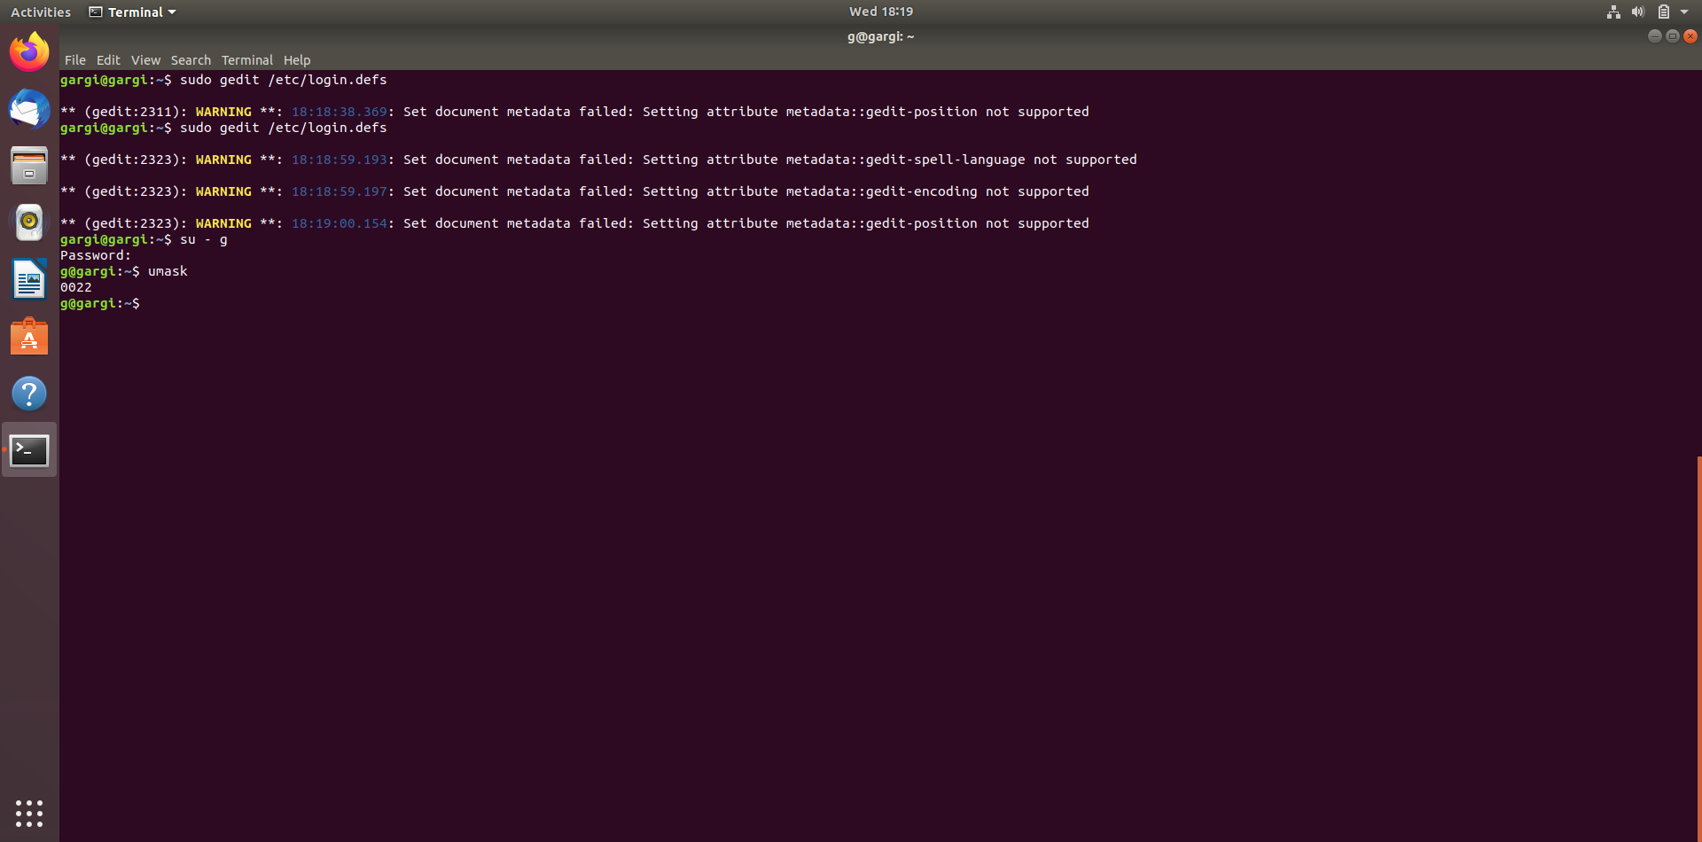

This is so because, maximum value that can be set as permission is 777 and default value of permission for any directory is calculated by subtracting the umask value from 777. Hence umask value cannot be more then 777. Hence umask value cannot be 0888.

**Q4. How to add a new user with a unique user id(e.g. 1345) and check out the unique id of that user.**

**Solution:** To add user with a specific user id (e.g. 1345), **-u** option will be used with **useradd** command. The syntax will be:

$sudo useradd –u 1345 jack

Here, sudo is used since not logged in to root account and jack is the username.

To check the user id (UID) of a user, use the command: $id –u jack

Following are the screenshots of the commands and output in ubuntu and the new user entry in the /etc/passwd file:

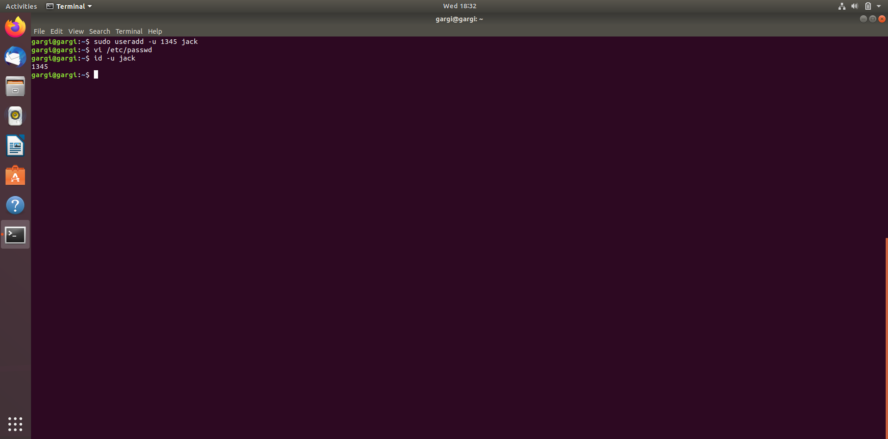

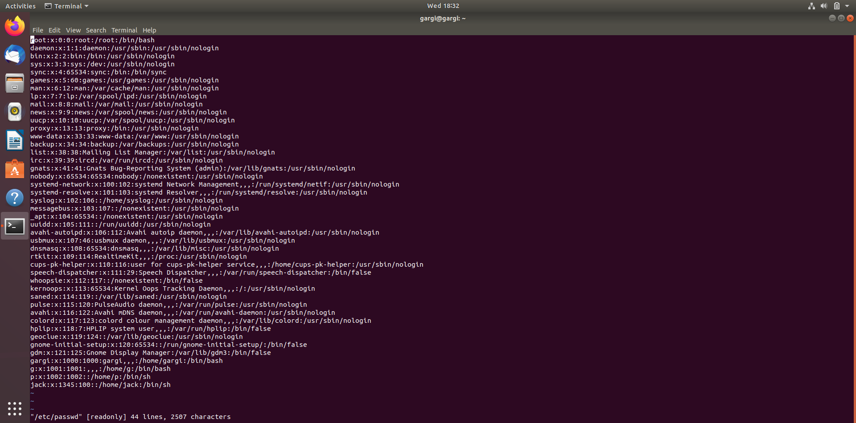

**Q5 How to change the group of any folder?**

**Solution:** We can change group of any folder with the help of **chgrp** command. First we need to create a new group which will become the new group of the directory ( say mydir ).

Following screenshot has the steps to create a new group and to change the group of the folder.

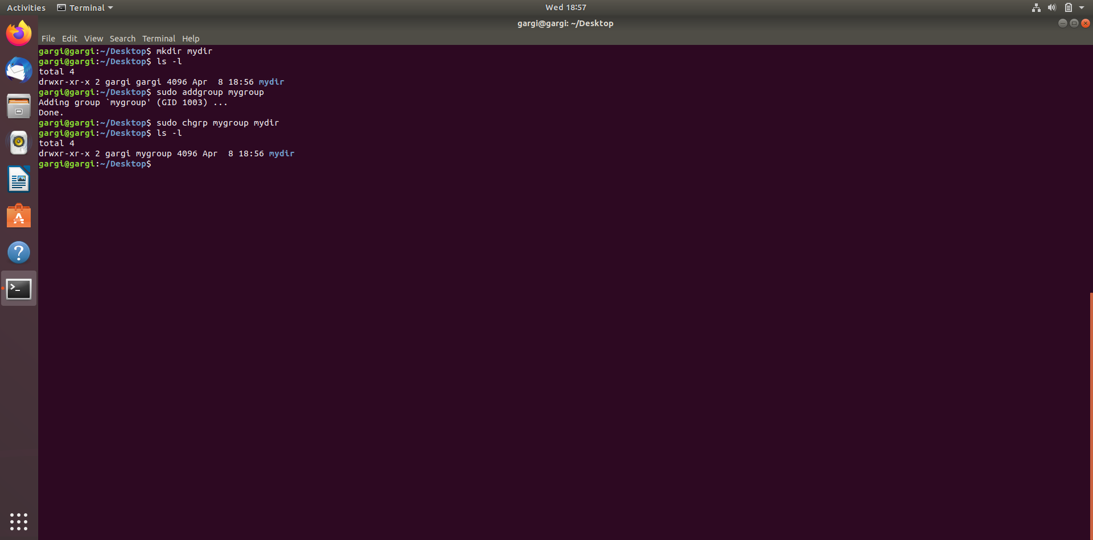

**Q 5(a) Checkout the group name of the files present in that folder.**

**Q. 5(b) Try to change the group of the folder & the files present in the same folder using a single command**

**Solution: (a)**To check the group name of the files present in that folder, **ls -l filename** command is used. On executing this command, it is noticed that the group name is same which was assigned by default, that is, the username itself which is  **gargi** in my case. To change the group name of any file either we can explicitly change the group name.

**(b)** to set the same group name as of the folder to all the files present in it, use the option **–R** along with the chgrp command.

Following screenshot shows the commands executed.

